**About Dataset**

**Brazilian E-Commerce Public Dataset by Olist**

Welcome! This is a Brazilian ecommerce public dataset of orders made at [Olist Store](http://www.olist.com/" \t "_blank). The dataset has information of 100k orders from 2016 to 2018 made at multiple marketplaces in Brazil. Its features allows viewing an order from multiple dimensions: from order status, price, payment and freight performance to customer location, product attributes and finally reviews written by customers. We also released a geolocation dataset that relates Brazilian zip codes to lat/lng coordinates.

This is real commercial data, it has been anonymised, and references to the companies and partners in the review text have been replaced with the names of Game of Thrones great houses.

## Data Schema

The data is divided in multiple datasets for better understanding and organization. Please refer to the following data schema when working with it:  
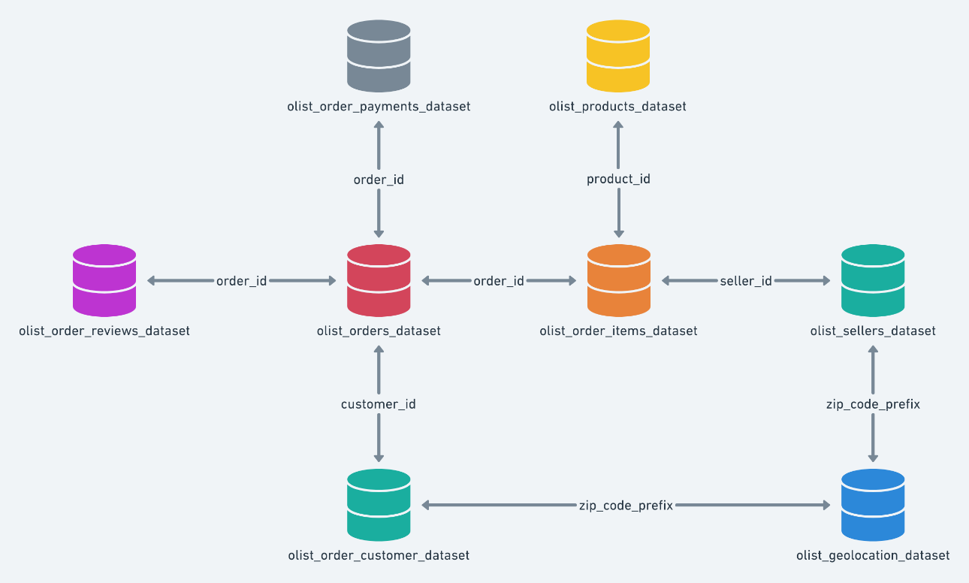

## Classified Dataset

We had previously released a classified dataset, but we removed it at Version 6. We intend to release it again as a new dataset with a new data schema. While we don't finish it, you may use the classified dataset available at the Version 5 or previous.

## Inspiration

Here are some inspiration for possible outcomes from this dataset.

**NLP:**  
This dataset offers a supreme environment to parse out the reviews text through its multiple dimensions.

**Clustering:**  
Some customers didn't write a review. But why are they happy or mad?

**Sales Prediction:**  
With purchase date information you'll be able to predict future sales.

**Delivery Performance:**  
You will also be able to work through delivery performance and find ways to optimize delivery times.

**Product Quality:**  
Enjoy yourself discovering the products categories that are more prone to customer in satisfaction.

**Feature Engineering:**  
Create features from this rich dataset or attach some external public information to it.